Microsoft 365 Virtual Marathon

Attendee Guide

Contents

1 Overview 2

2 Conference Best Practices 3

3 Joining Sessions 3

3.1.1 Join Links to Access Live Events 3

3.1.2 Schedule 4

3.1.3 Sessions 4

3.1.4 Speakers 4

3.1.5 Sponsors 4

3.1.6 Attending the live event on the web version of Microsoft Teams 4

4 Participating in the Live Event 5

4.1 How to Use Closed Captioning and Subtitles 5

4.1.1 Adjusting the Resolution 5

4.2 How to Ask Questions 6

5 Community Zone 6

6 Sponsor Rooms 6

7 Event Raffle 7

8 Donations 7

9 Conference Code of Conduct 7

10 FAQ 8

# Overview

Microsoft 365 Virtual Marathon is a free online, 36-hour event happening May 27-28, 2020. We have sessions going the whole time with speakers from around the globe. This event is free for all wanting to attend. Join us as we talk about the many different pieces of Microsoft 365, including Azure.

We have sessions in English, French, German, Japanese, Korean, Portuguese, and Spanish. All English sessions (Microsoft Teams limitation) will have live captions, and live translation enabled for the other languages. Session recordings will be posted to our YouTube channel, <https://bit.ly/M365VMYoutube>, after the event. Some sessions may not be available due to content restrictions that our speakers are under.

Microsoft 365 Virtual Marathon is a joint effort with [SPC](https://www.sharepointna.com/) and members of the Office 365 community.

We have keynotes from key Microsoft employees and sessions from thought leaders and members of the community from around the world.

# Conference Best Practices

1. Ensure you have a stable internet connection
2. Ensure you have downloaded [Microsoft Teams](https://www.microsoft.com/en-us/microsoft-365/microsoft-teams/download-app) or are prepared to join live events from a browser-based Teams instance.
   1. Use a media-source extension (MSE)-enabled web browser like Chrome, Firefox, or Edge.
   2. Safari is not currently supported.
3. If you are in a meeting, such as a sponsored room, mute your microphone to avoid any distracting background noise.
4. Use your webcam – turn on video during meetings to provide a personal connection with other attendees.
   1. Be mindful of your surroundings. Make sure your background is well-lit, but not too bright.
   2. **Teams Tip**: Enable the ‘background blur’ option to reduce the amount of visual noise surrounding you by clicking on the **Ellipsis** icon from the meeting options and choose Blur My Background. For an added touch, choose one of the custom background images and add your own flair.

# Joining Sessions

You can navigate the conference sessions, sponsor room, and community zone through the [conference website](http://www.m365virtualmarathon.com). Use the site navigation headings to view the pages containing the information of interest.

### Join Links to Access Live Events

1. All sessions can be accessed by navigating to the [conference schedule](http://www.m365virtualmarathon.com/schedulewithjoin.html).
2. Locate the session of interest and click on the session title

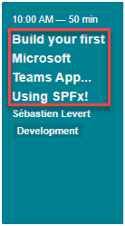

1. Click on the Join button

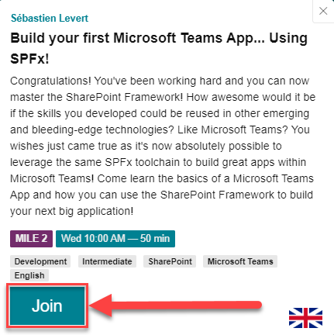

### Schedule

To view the conference schedule, click on the [Schedule Heading](http://www.m365virtualmarathon.com/schedulewithjoin.html) on the conference website.

### Sessions

To view a list of all sessions, click on the [Sessions Heading](http://www.m365virtualmarathon.com/sessions.html) on the conference website.

### Speakers

To view a list of all speakers, click on the [Speakers Heading](http://www.m365virtualmarathon.com/speakers.html) on the conference website.

### Sponsors

To view a list of all sponsors, click on the [Sponsors Heading](http://www.m365virtualmarathon.com/sponsors.html) on the conference website.

### Attending the live event on the web version of Microsoft Teams

If you choose to “Watch on the web” instead of downloading the Microsoft Team application, before watching a live event:

* Make sure your browser allows third-party cookies.
* Ensure your browser supports Microsoft Teams and Microsoft Azure Media Player.



# Participating in the Live Event

## How to Use Closed Captioning and Subtitles

1. To turn on live captions and subtitles, select Captions/Subtitles On in your video controls.
2. To change the caption language, select Settings > Captions/Subtitles, and choose the language you want.

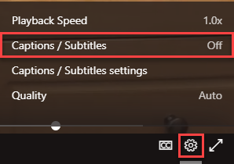

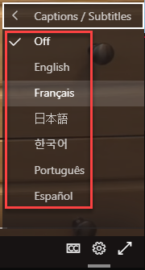

### Adjusting the Resolution

If the live event begins in low resolution, you might need to reset it to a higher resolution manually.

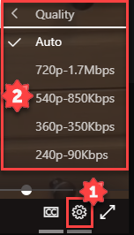

## How to Ask Questions

The Q&A will open by default, and you can start asking questions even if the event has not started.

1. Select Q&Aon the right side of the screen.
2. Type your question in the compose box, and then select Send. If you want to ask your question anonymously, select Ask anonymously.

# Community Zone

As part of the Microsoft 365 Virtual Marathon, we are offering a Community Zone in Virtual Reality. In the community zone, we have a viewing area for keynotes, along with areas for socializing and playing games. The community is hosted in [AltspaceVR](https://altvr.com/). AltspaceVR offers virtual reality interaction along with a 2D non-VR mode.

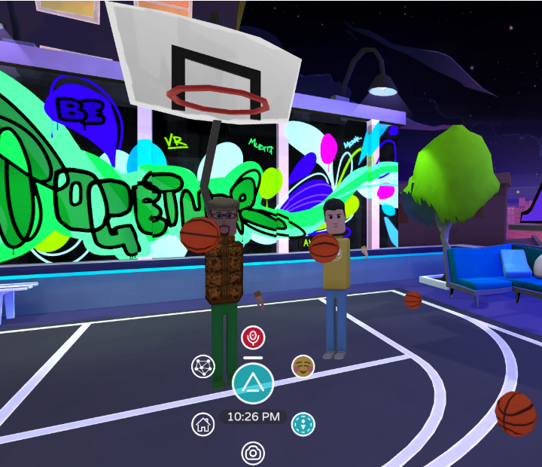

To participate, you need to install one of the applications for your device or desired connection method. <https://altvr.com/get-altspacevr/>

Sign up and create an account if you have not already done so, <https://account.altvr.com/users/sign_up>.

When the time comes, join the fun at [Community Zone](altspace://account.altvr.com/api/spaces/meeting-hall---m365-community-9337) (Link only works if the AltspaceVR app is installed).

# Sponsor Rooms

Thank you to all our generous sponsors. Sponsor booths are hosted as Microsoft Teams Meetings. To visit a sponsor booth navigate to the Sponsors page on the [conference website](http://www.m365virtualmarathon.com), then click on the Join button associated with each sponsor.

# Event Raffle

We are giving away THREE Oculus Quest All In One! To enter the raffle complete the following:

1. Visit the vendor booths, sessions, and watch the videos.
2. Submit your answers at the following link - https://bit.ly/m365raffle
3. You need at least 5 correct answers and then submit for a chance to win one the devices.

# Donations

Consider donating to the charity relief funds below. 10% of funds from sponsors goes to support community relief. For more information contact [info@m365virtualmarathon.com](mailto:info@m365virtualmarathon.com).

**United Way:** [**HTTPS://GIVE.UWKC.ORG/M365VM**](HTTPS://GIVE.UWKC.ORG/M365VM)

**International Medical Corps:** [**HTTPS://BIT.LY/MEDICALCORPSFUND**](HTTPS://BIT.LY/MEDICALCORPSFUND)

# Conference Code of Conduct

The following code of conduct outlines our expectations of the behaviors we consider unacceptable.

* Personal insults, threats, attacks, harassment, stalking, abuse, slurs, profanity, sexual remarks or innuendos, or physical violence directed against another person particularly those related to gender, sexual orientation, race, religion, or disability or otherwise discriminatory jokes and language
* Inappropriate physical contact or unwelcome sexual attention, including sexualized comments or jokes, inappropriate touching, groping, or unwelcome sexual advances
* Posting or displaying sexually explicit or violent material.
* Deliberate intimidation, stalking, or following (online or in-person).
* Advocating for or encouraging any of the above behavior.
* Sustained disruption of conference events, including talks and presentations

Anyone asked to stop unacceptable behavior is expected to comply immediately. If an attendee, speaker, producer, sponsor, or conference organizer engages in unacceptable behavior, the conference organizers will take any action they deem appropriate, including expulsion from the conference. This includes all spaces related to the conference, virtual and physical.

If you are subject to or witness unacceptable behavior, please notify the conference organizers at [info@m365virtualmarathon.com](mailto:info@m365virtualmarathon.com)

# FAQ

**Q**: What steps should I take before the event?

**A**: If you have not already, download Microsoft Teams to your device and add [info@m365virtualmarathon.com](mailto:info@m365virtualmarathon.com) to your list of safe senders for the upcoming invitation.

**Q**: Who do I contact if I am not able to login to Microsoft Teams?

**A**: Please reach out directly to the conference organizers at [info@m365virtualmarathon.com](mailto:info@m365virtualmarathon.com), and we will triage your issue for support to resolve it.

**Q**: Where can I find more information about what I can do in Teams as a guest?

**A**: The guest experience does have some limitations. For more information, please refer to this [document](https://docs.microsoft.com/en-us/MicrosoftTeams/guest-access#understand-the-limitations-for-guests) for additional details.

**Q**: Am I able to access a recording or download information/decks presented during the session?

**A**: All sessions will be recorded, and individual session recordings will be posted to the YouTube channel for the event, <https://bit.ly/M365VMYoutube>